

**LAB 6 MANUAL**(243515)

**Visual Programming (VP)**

**Name: Muhammad Maaz Rasheed**

**Roll No: 243515**

**Semester: Third Semester**

**Section: BSCS(B)**

**Title: Lab 6**

**Task 1:**

using System;

using System.Collections.Generic;

using System.ComponentModel;

using System.Data;

using System.Drawing;

using System.Linq;

using System.Text;

using System.Threading.Tasks;

using System.Windows.Forms;

namespace WindowsFormsApp1

{

public partial class Form1 : Form

{

public Form1()

{

InitializeComponent();

}

private void button1_Click(object sender, EventArgs e)

{

string x =textBox1.Text;

label2.Text = x;

}

}

}

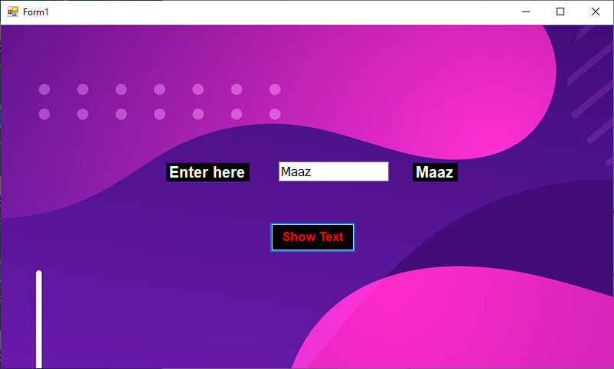

**Task 2:**

using System;

using System.Collections.Generic;

using System.ComponentModel;

using System.Data;

using System.Drawing;

using System.Linq;

using System.Text;

using System.Threading.Tasks;

using System.Windows.Forms;

namespace WindowsFormsApp1

{

public partial class Task2 : Form

{

public Task2()

{

InitializeComponent();

}

private void button1_Click(object sender, EventArgs e)

{

string skill = null;

if (checkBox1.Checked) skill += " C#";

if (checkBox2.Checked) skill += " Python";

string gender = null;

if (radioButton1.Checked) gender += " Male ";

if (radioButton2.Checked) gender += " Female ";

MessageBox.Show($"Your skill:{skill}.\nYour Gender:{gender}.");

}

}

}

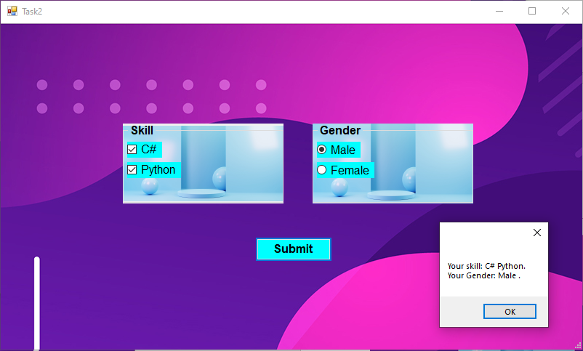

**Task 3:**

using System;

using System.Collections.Generic;

using System.ComponentModel;

using System.Data;

using System.Drawing;

using System.Linq;

using System.Text;

using System.Threading.Tasks;

using System.Windows.Forms;

namespace WindowsFormsApp1

{

public partial class Task3 : Form

{

public Task3()

{

InitializeComponent();

}

private void button1_Click(object sender, EventArgs e)

{ string item=null;

string list = null;

foreach (string x in checkedListBox1.CheckedItems)

{

item += " " + x;

}

list = listBox1.Text;

MessageBox.Show($"You selected: {list} from list box and\nYou selected:{item} from Checked list box");

}

}

}

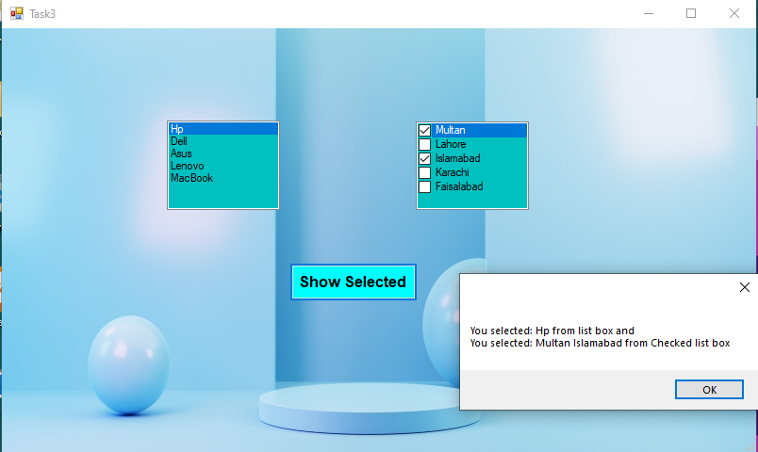

**Task 4:**

using System;

using System.Collections.Generic;

using System.ComponentModel;

using System.Data;

using System.Drawing;

using System.Linq;

using System.Text;

using System.Threading.Tasks;

using System.Windows.Forms;

namespace WindowsFormsApp1

{

public partial class Task4 : Form

{

public Task4()

{

InitializeComponent();

}

private void button1_Click(object sender, EventArgs e)

{

string x=comboBox1.Text;

string y=numericUpDown1.Text;

Convert.ToInt32(y);

MessageBox.Show($"Your Selected Country: {x}\nYour age: {y}");

}

}

}

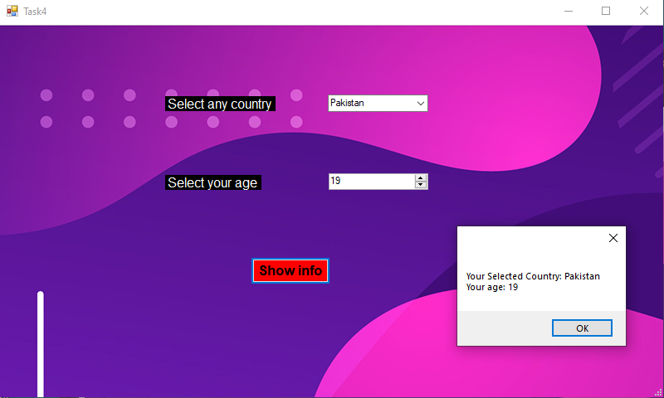

**Task 5:**

using System;

using System.Collections.Generic;

using System.ComponentModel;

using System.Data;

using System.Drawing;

using System.Linq;

using System.Text;

using System.Threading.Tasks;

using System.Windows.Forms;

namespace WindowsFormsApp1

{

public partial class Task5 : Form

{

public Task5()

{

InitializeComponent();

}

private void button1_Click(object sender, EventArgs e)

{

string y=null;

string x = null;

if (checkBox1.Checked) x += checkBox1.Text+" ";

if(checkBox2.Checked) x += checkBox2.Text+" ";

if(checkBox3.Checked) x += checkBox3.Text+" ";

if(radioButton1.Checked) y= radioButton1.Text;

if (radioButton2.Checked) y= radioButton2.Text;

label1.Text =$"You selected {x} from groupbox\nYou selected {y} from panel";

}

}

}

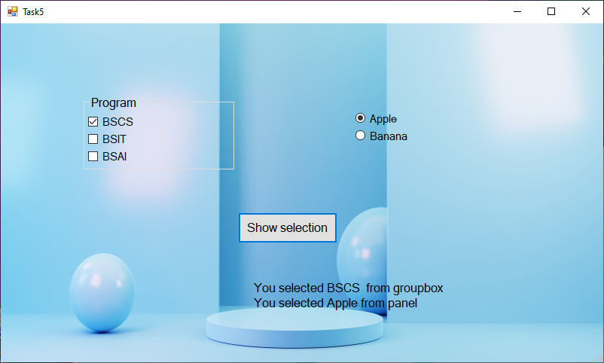

**Task 6:**

using System;

using System.Collections.Generic;

using System.ComponentModel;

using System.Data;

using System.Drawing;

using System.Linq;

using System.Text;

using System.Threading.Tasks;

using System.Windows.Forms;

namespace WindowsFormsApp1

{

public partial class Task_6 : Form

{

public Task_6()

{

InitializeComponent();

}

private void button1_Click(object sender, EventArgs e)

{

label1.Text = "You selected date: "+dateTimePicker1.Text;

}

}

}

